**Department of Electrical Engineering and   
Computer Science**

**Faculty Member:** Ma’am Neelma Naz **Dated:** 21/09/2022

**Semester:** 6th **Section:** BEE 12C

## EE379: Control Systems

# LAB 3: System Modeling

**Lab Instructor: Sir. Yasir Rizwan**

**Group Members**

|  |  |  |  |  |
| --- | --- | --- | --- | --- |
| Student Name | Reg. No. | Lab Report Marks / 10 | Viva Marks  / 5 | Total  /15 |
| **Muhammad Ahmed Mohsin** | **333060** |  |  |  |
| **Imran Haider** | **332569** |  |  |  |
| **Zafar Azhar** | **340908** |  |  |  |
|  |  |  |  |  |

Table of Contents

EE379: Control Systems 1

LAB 3: System Modeling 1

System Modeling and Simulation in Simulink Introduction 3

Objectives 3

Software Used 3

Introduction 3

Lab Task 1: 4

Modeling of DC Motor 4

Home Tasks: 5

Task 1: 5

Solution: 6

Task :2 6

Solution: 6

TASK 3 8

Note: 8

Solution: 8

Code: 8

OUTPUT: 9

TASK: 4 10

OUTPUT: 10

Task: 5 10

Solution: 11

Conclusion: 13

## System Modeling and Simulation in Simulink Introduction

## Objectives

1. Learn the modeling of a DC motor using first principles.
2. Given a set of differential equations that describe a system, learn how to create a model in Simulink.
3. Given a set of differential equations describing a system, learn how to find the transfer function of the system.

## Software Used

* MATLAB

Figure .: MATLAB logo

## Introduction

Modeling is the process of finding a mathematical model of a system. A mathematical model is a description of a system and helps us to understand the behavior of that system. Obtaining a model is usually the first step in controller design. In this handout we will see how we can derive a model using first principles. First principles are the established physical laws, e.g. Kirchhoff’s voltage law, Newton’s laws of motion, etc. Modeling based on first principles doesn’t involve the value of system parameters like mass, spring constant etc. These parameter should either be known or have to be estimated using system identification techniques. Dynamical systems have some quantity that changes with time, and therefore the rate of change of that quantity is often necessary to describe that dynamical system. For this reason, most of the dynamical systems can be modeled with a set of differential equations. In this handout we will derive the model of a DC motor using first principles and will see that it is also a set of differential equations. In some cases, the model is provided by the system manufacturer/designer and we don’t have to find out the differential equation ourselves. Once we have a set of differential equations, we will see how to represent those differential equations (or the dynamical system) in Simulink. We will also learn how to find a transfer function of a system from a set of differential equations.

# Lab Task 1:

## Modeling of DC Motor

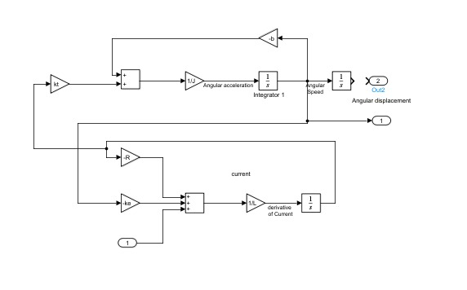

# Home Tasks:

## Task 1:

Using equations (9) and (10), make a model of the rotary inverted pendulum in Simulink. For the parameters, use the values given in the table above, which are for the QNET inverted pendulum available in our control laboratory.

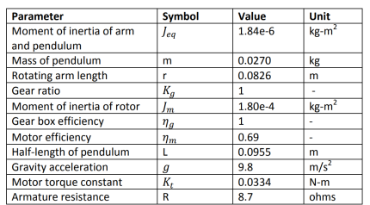

## Solution:

By using the equations shown below we form the following system in Simulink:

# Task :2

Use the set differential equations and the Laplace transforms to find the following transfer functions (Perform this on paper and attach scans/photos in lab report).

1. Transfer function between the speed and voltage of the motor
2. Transfer function between the position and voltage of the motor
3. Transfer function between the position of the pendulum and voltage of the of the attached motor

## Solution:

The handwritten transfer functions are shown below:

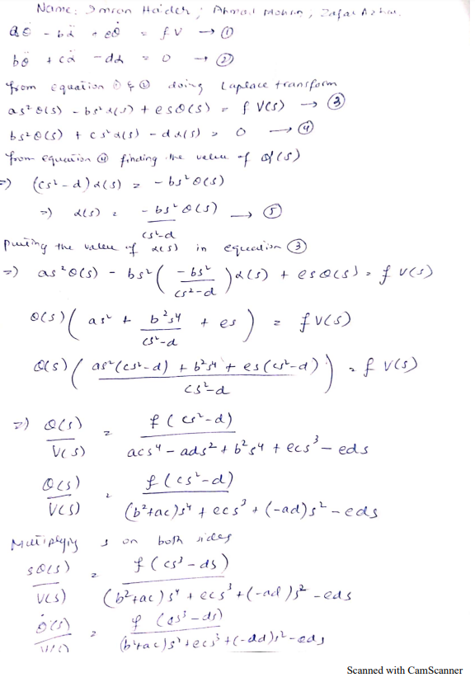

# TASK 3

Using the things, you have learnt in lab 1, create all the transfer functions of Exercise 2 in MATLAB.

## Note:

Always use m files when working in MATLAB so that you can save them.

## Solution:

The code for the given task is as shown below:

### Code:

%% Variables

J_eq = 1.843e-6;

m = 0.0270;

r = 0.0826;

K_g = 1;

J_m = 1.80e-4;

n_g = 1;

n_m = 0.69;

L = 0.0955;

g = 9.9;

K_t = 0.0334;

R = 8.7;

a = J_eq + m * r ^ 2 + n_g * K_g ^ 2 * J_m;

b = m * L * r;

c = (4/3) * m * L ^ 2;

d = m * g * L;

e = 2.7183;

f = (n_m * n_g * K_t * K_g) / R;

%first transfer function

num1=[-c 0 f*d 0];

den1=[(b^2-a*c) -e*c a*d e*d 0];

T1=tf(num1,den1)

%second transfer function

num2=[-c 0 f*d];

den2=[(b^2-a*c) -e*c a*d e*d 0];

T2=tf(num2,den2)

%third transfer function

num = [-b*f 0 0];

den = [(a*c-b^2) e*c -a*d e*d 0];

T3 = tf(num, den)

## OUTPUT:

# TASK: 4

Using the things you have learnt in lab 1, create all the transfer functions of Exercise 2 in Simulink using the Transfer function block.

## OUTPUT:

The output for the transfer functions in Simulink is as shown:

# Task: 5

Using the lab 2 procedure, create all the transfer functions of Exercise 2 in LabVIEW.

## Solution:

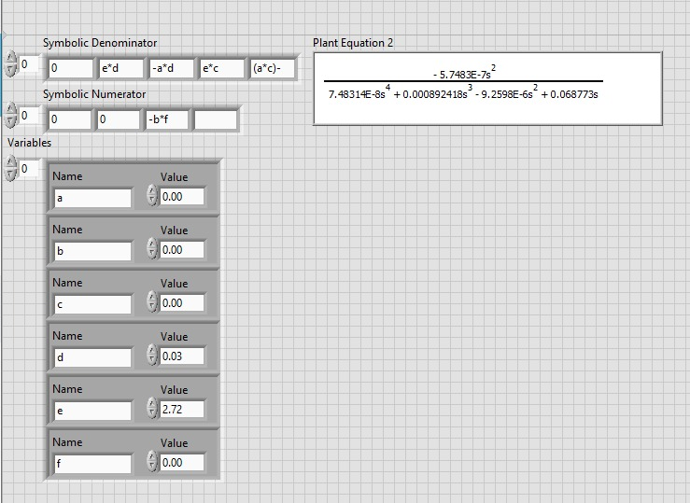

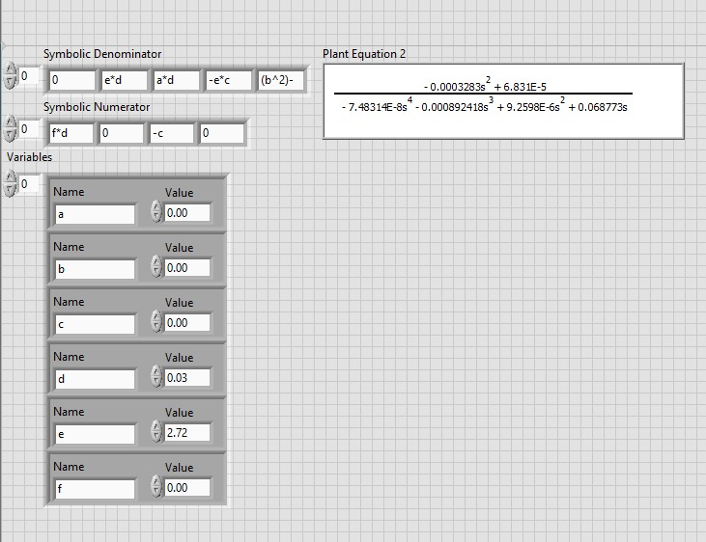

# Conclusion:

To summarize, the lab exercise presented a thorough and in-depth exploration of the modelling of a direct current (DC) motor, utilizing the fundamental principles of physics and mathematics. The practical application of the acquired knowledge was then demonstrated in the popular simulation software, Simulink. The process involved creating a comprehensive model of the DC motor system in Simulink, which was developed based on the mathematical framework of the system's differential equations. This allowed us to obtain an accurate representation of the system's behavior under different operating conditions. Furthermore, the exercise provided an opportunity to learn about the process of deriving the transfer function of a system, which is a key concept in the design and analysis of control systems for various applications. This knowledge is essential for understanding the behavior of complex systems and designing effective control strategies to achieve desired outcomes. Overall, the lab exercise has equipped us with valuable knowledge and skills in the area of DC motor modelling and control system design, which can be applied in a wide range of engineering and scientific applications. By gaining an in-depth understanding of the principles and tools involved, we are better prepared to tackle complex engineering problems and make informed decisions in a variety of context.